Unit 7 Assignment: Worker Training Module Plan
Note to Students: This template is provided for your convenience and to assist your learning related to developing professional documents using a template. Guidance in this template is matched to Level 4 of the associated rubric. Information in [brackets] should be replaced by you. Delete these instructions before submitting your assignment.
This project template is designed to help you create a worker training module plan based on a gap and needs analysis. You should include a list of learning evaluation methods to assess worker competency and a slide deck with speaker notes for a training session. The session should last 3 to 5 minutes for individual students or 6 to 8 minutes for teams of two students.

Ergonomic Risk Factor
For this training module plan, each student should select and identify one worker population (e.g., Grocery Store Clerks/Cashiers or Store Shelf Stockers and Order Fillers), one needed skill (e.g., related to materials handling activities), and one ergonomic risk factor (e.g., force, repetition, awkward and static postures, or contact stress).
Important: If you are working individually, you must provide information for one worker population. If you are working in a group of two students, you must provide information for two worker populations, but you can focus on the same ergonomic risk factor. Note: In retail grocery stores, there may be overlap between the daily tasks of grocery store clerks and store shelf stockers, as workers are often required to perform both roles to support operations. Therefore, creating a combined training module on one risk factor and how it applies to each worker population would be appropriate.
- Worker Population #1: [Identify selected worker population.]
  - Needed Skill: [List.]
  - Related ergonomic risk factor: [Select from force, repetition, awkward and static postures, or contact stress.]
Hint: If you are unsure which ergonomic risk factor to choose, review your Unit 4 Assignment where you identified the related physical and cognitive ergonomic risk factors for your selected worker population.

Training Module Design Process
Summarize how your just-in-time (JIT) worker training module was designed to follow each stage of the Analysis, Design, Development, Implementation, and Evaluation (ADDIE) Model. This approach will be most effective if a team of two students works on a training module focused on the same ergonomic risk factor as it applies to both worker populations.

Analysis Stage
Briefly explain the process of conducting a training needs analysis and a skills gap analysis in 1 to 2 sentences.
Important: If you are working individually, you must provide information for one worker population. If you are working in a group of two students, you must provide information for two worker populations.
- Analysis: [Describe how you performed a training needs analysis for Worker Population #1 (e.g., demographics, literacy, previous knowledge) and what the findings of the needs analysis were.]
Table 1. Training Needs Analysis for [Worker Population #1] for [materials handling activity].
Hazard | Current Controls | Additional Controls Needed | Skills Needed to Work Safely | Training Currently Provided | Other Training Needed
[List] | [List] | [List] | [List] | [List] | [List]
Briefly summarize the process of conducting the skills gap analysis and the results of this analysis in 1 to 2 sentences.

Design Stage
Briefly explain how you designed the JIT training module, including the selection of learning objectives and the rationale behind the organization of the presentation.
Important: If you are working individually, you must provide at least 1 learning objective and information for 6 slides, including 3 unique content slides. If you are working in a group of 2 students, you must provide at least 2 learning objectives and information for a total of 9 slides, including 6 unique content slides about the ergonomic risk factor as it applies to both worker populations.
- Design: [Describe how you designed the structure of the worker training module and how many total slides were made.]
Learning Objectives
After completing this training module, the worker will be able to:
- [Learning objective #1 with action verb, e.g., “Recognize the steps of a hazard assessment for protective footwear.”]
Training Module Design
- Title Slide: [Name of JIT Training Module]
- Introduction slide with learning objectives
- Content slide about [topic]
- Content slide about [topic]
- Content slide about [topic]
- Resources slide
The purpose of your training module is to increase worker knowledge about an ergonomic risk factor related to the new skill they will be expected to perform and to assess their competency in using this knowledge and/or performing the new skill.

Development Stage
Briefly explain how you incorporated adult learning theory and/or techniques and Universal Design for Learning (UDL) principles in your worker training module. Describe how the content is accurate, credible, clear, and practical. Ensure you include attributions for images used, even if they are from Creative Commons sites.
Important: If you are working individually, you must provide information for one worker population. If you are working in a group of two students, you must provide information for two worker populations.
- Development: [Describe how you developed the content for the training module for Worker Population #1 and where the information and images were sourced from.]

Training Module Speaker Notes
The speaker notes are [XXX] words in total, representing an approximately [3-minute or 6-minute] presentation.
Important: If you are working individually, you must provide speaker notes equivalent to at least a 3-minute presentation (375 to 450 words). If you are working in a group of two students, you must provide speaker notes equivalent to at least a 6-minute presentation (750 to 900 words).
Copy your speaker notes from the JIT training module slide deck into this section. Include the word count for each slide in parentheses at the end of each slide note, as shown in the example below.
- Slide 1. [Example: We are Fancy Chefs! Selecting your new footwear. This interactive training module is about collaborating to conduct a hazard assessment to select new footwear for the Chefs and Head Cooks at Fancy Chefs.] (35 words)
- Slide 2. [Speaker notes.] (XX words)
- Slide 3. [Speaker notes.] (XX words)
- Slide 4. [Speaker notes.] (XX words)
- Slide 5. [Speaker notes.] (XX words)
- Slide 6. [Speaker notes.] (XX words)

Implementation Stage
Briefly describe how the JIT training module will be implemented. Will it be provided as in-person training, interactive computer-based training, a recorded video, or within a mobile app? Which participatory training methods will be used in the module? Can workers ask questions during the training?
Important: If you are working individually, you must provide information for one worker population. If you are working in a group of two students, you must provide information for two worker populations.
- Implementation: [Describe how you plan to present or otherwise deliver this training module to Worker Population #1.]
You do not need to record yourself giving the presentation for this assignment. An example slide with speaker notes is provided below to help you correctly place the speaker notes within your slide deck
Figure 1. Screenshot of PowerPoint software within the web-based Office 365 app, demonstrating how to view and add notes to a slide deck. First, select “View” in the upper ribbon, and if using “Normal” as the Presentation View, select “Notes” in the Show tab. Or select “Outline View” as the Presentation View and then select “Notes” in the Show tab. Type the speaker notes in the gray area beneath the slide as shown.
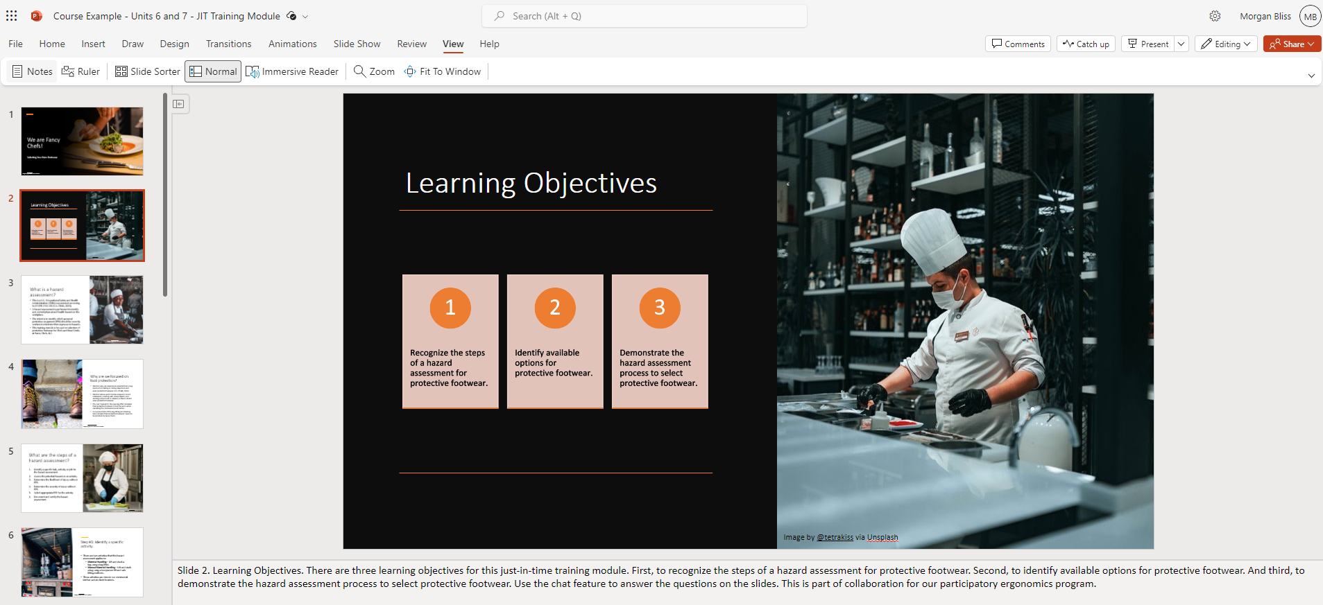

Evaluation Stage
Summarize how you plan to evaluate the transfer of learning for the workers after they complete the training module. Specify which worker competency will be assessed (e.g., the work-related skill and behavior needed to perform work activities safely).
Important: If you are working individually, you must provide information for one worker population. If you are working in a group of two students, you must provide information for two worker populations.
- Evaluation: [Describe how you will evaluate the learning and competency for Worker Population #1 during or after completion of the worker training module.]

Worker Competency
Use this section to list and detail the components of the worker competency evaluation.
- Competency: The [Worker Population #1] + [action verb with specific skill] + to [action verb with specific behavior]
- Person: [Worker Population #1]
- Skill: [Describe]
- Behavior: [Describe]
Learning-Transfer Evaluation Method (LTEM) Possibilities
Which Learning-Transfer Evaluation Model (LTEM) tier does your preferred evaluation method use? Include the possible evaluation methods (e.g., smile sheet, quiz, demonstration instructions, etc.) in the table below.
Important: If you are working individually, you must provide information for one worker population. If you are working in a group of two students, you must provide information for two worker populations.
Table 2. Evaluation methods that could be used in the training module about [ergonomic risk factor] for [Worker Population #1].
Tier | Name of Tier | Description of Evaluation Methods for [Worker Population #1]
1 | Attendance | [Describe.]
2 | Activity | [Describe.]
3 | Learner Perceptions | [Describe.]
4 | Knowledge | [Describe.]
5 | Decision-Making Competence | [Describe.]
6 | Task Competence | [Describe.]
7 | Transfer | [Describe.]
8 | Effects of Transfer | [Describe.]

Scenario
Imagine that your manager reviews this Worker Training Module Plan and emails you back, writing: “Hi, this all seems great. Very thorough. It also seems expensive, and I think it will take far too much effort, considering it’s just-in-time training. Look, I found this presentation online from some fancy expert consultant who specializes in retail ergonomics. Just use this one – you know what they say in safety, to rip off and duplicate is easier than doing your own research and development - it’s the more efficient R&D. [laughing emoji] And honestly, no one will know that we used the consultant’s presentation without permission. The lady probably makes a ton of money from her consulting and if it’s free online, it’s free to use, in my opinion. Can’t you just upload the consultant’s presentation to our training app and do a quick voice-over reading of what’s on the slides? You’re not even certified in ergonomics, so I don’t see the point of you wasting your time learning it all and doing the training. Let me know when it’s done and ready for roll-out.”
How would you respond to your manager? What is the best way to handle this unethical situation? How can you choose collaborative and ethical practices to build relationships as an entry-level professional? How will you determine the appropriate action to take, considering your knowledge limitations and the power dynamics in this situation? Use at least one standard (per student) from the Board of Certified Safety Professionals (BCSP; 2022) Code of Ethics to support your concerns about your manager’s request.
Important: If you are working individually, you must support your response with at least one standard from the BCSP Code of Ethics. If you are working in a group of two students, you must support your response with at least two standards from the BCSP Code of Ethics.
[Enter your response to the ethical scenario here.]

Reflection
Reflect on the activities you performed for this assignment. How long did it take you and/or your partner to complete it? Have you done this type of worker training planning before? Have you used PowerPoint in your personal or professional life? What skills do you think you learned from this assignment, and how can they benefit you in your future career?
[Enter your reflection here.]

Attachments
- JIT Training Module for [Worker Population #1] about [Ergonomic Risk Factor], uploaded as a .pptx [or .pdf] file with speaker notes present and viewable

References
[Insert APA-formatted reference to resources used, such as the BCSP Code of Ethics, where applicable.]
Board of Certified Safety Professionals [BCSP]. (2022, November 04). Code of ethics. Policies & Forms. https://www.bcsp.org/hubfs/8981246/Downloads-PDFs-and-PPTs/BCSPcodeofethics.pdf
U.S. National Institute for Occupational Safety and Health. (2014). Ergonomic Solutions for Retailers: Prevention of Material Handling Injuries in the Grocery Sector (Publication No. 2015-100). Centers for Disease Control and Prevention. https://www.cdc.gov/NIOSH/docs/2015-100/default.html
U.S. Occupational Safety and Health Administration. (2004). Guidelines for retail grocery stores: Ergonomics for the prevention of musculoskeletal disorders (Document No. OSHA 3192-06N). U.S. Department of Labor. https://www.osha.gov/sites/default/files/publications/osha3192.pdf

